Growth Curve Analysis: How Capital Investment
Translates into Long-term Commercial Value for
VC-backed Startups

Student Name: Lingke Huang (20720152)
Introduction
Venture capital (VC) is widely regarded as a catalyst for innovation, yet the relationship
between capital investment and startup success remains poorly understood. This study
investigates a focused research question: In the VC ecosystem, what patterns of capital
investment are most strongly associated with successful exit outcomes (IPO or acquisition)? I decompose “capital investment” into three measurable dimensions — volume (total funding), milestones (number of funding rounds), and velocity (time between rounds) — and examine how each dimension relates to the binary outcome of exit success. By operationalizing a broad business question into testable sub-questions, this analysis aims to move beyond anecdotal claims and let the data reveal the structural patterns behind startup outcomes.
Method
Data source: The analysis draws on the Crunchbase open dataset, a widely cited source in
entrepreneurship research (Block & Sandner, 2009). I utilize four relational tables —
objects.csv (company master), funding_rounds.csv (round-level records), acquisitions.csv,
and ipos.csv — joined via the company identifier. After filtering for entities classified as
companies, with confirmed funding greater than zero and a valid status label (operating,
acquired, ipo, or closed), the working sample comprises 27,874 VC-backed companies
across 42 industry categories.

Feature engineering: Three independent variables were constructed — (i) total funding,
binned into six tiers from under $1M to over $500M; (ii) number of funding rounds, as a
discrete count capped at 10+; and (iii) average time between rounds, computed as the
mean inter-round interval in months and binned into five speed categories. The
dependent variable is a binary indicator of exit success, coded as 1 if the company
achieved an IPO or was acquired, and 0 otherwise. The overall baseline exit rate in the
sample is 10.1%.

Tools: Data wrangling was performed with pandas and NumPy in Python. Visualisation
employed two complementary packages: Plotly (graph_objects and express) for the
interactive TreeMap, stacked bar chart, and bubble chart (Figs 1–3), and seaborn with
Matplotlib for the annotated heatmap (Fig 4). A unified professional colour palette was
applied across all figures for visual coherence.
Result
- Fig 1 (EDA Overview) presents a hierarchical TreeMap of the dataset’s 12 largest industries, with rectangle area encoding company count and four discrete colours distinguishing exit status (Operating, Acquired, IPO, Closed). Software and Web dominate the ecosystem by volume, while Biotech shows a comparatively higher exit-success proportion — its IPO and Acquired tiles are visibly prominent relative to its size — suggesting that industry context moderates the funding–exit relationship.
- Fig 2 (RQ1: Volume) decomposes exit rate by funding bracket into IPO rate and acquired rate using a stacked bar chart, with sample size plotted on a secondary axis. Exit rate rises monotonically from 3.0% (under $1M) to 42.1% (over $500M). Notably, the composition shifts: in lower brackets, acquired exits dominate, while in the highest bracket, the IPO rate alone reaches 36.8%. The overall average exit rate (10.1%) serves as a baseline reference line.
- Fig 3 (RQ2: Milestones) maps exit rate against funding round count using a bubble chart, where bubble size encodes sample size and color encodes exit rate. A first-difference analysis identifies Round 10 as the threshold where exit rate jumps most sharply (+14.2 percentage points, from 13.0% to 27.3%). The pattern is non-linear: exit rates plateau around Rounds 3–5 at approximately 15%, dip at Round 9, and surge for companies surviving to Round 10 or beyond.
- Fig 4 (RQ3: Velocity × Volume) uses a cross-tabulated heatmap to simultaneously examine funding speed and funding amount. Companies with inter-round intervals of 6–24 months consistently show the highest exit rates across funding brackets. The pattern holds even when controlling for funding volume, indicating that funding velocity has an independent association with exit success. One cell (over $500M, interval exceeding 48 months) reaches 100%, though with only n = 1, demanding cautious interpretation.
Discussion
All three research questions are addressed with empirical evidence. The results suggest
that moderate-to-high funding volume, sufficient round milestones, and a measured funding
cadence collectively characterize the most successful startups. The monotonic rise
observed in Fig 2 challenges the initial hypothesis of diminishing returns — although this
may reflect reverse causality, whereby successful companies attract more capital rather
than capital causing success. The Round 10 threshold identified in Fig 3 likely reflects a
selection effect: companies surviving to late rounds have already passed multiple rounds of
investor due diligence (Gompers & Lerner, 2001).
References
[1] Block, J. & Sandner, P. (2009). What is the effect of the financial crisis on venture capital
financing? Empirical evidence from US Internet start-ups. Venture Capital, 11(4), 295–309.
[2] Cochrane, J.H. (2005). The risk and return of venture capital. Journal of Financial
Economics, 75(1), 3–52.
[3] Gompers, P. & Lerner, J. (2001). The venture capital revolution. Journal of Economic
Perspectives, 15(2), 145–168.
[4] Kaplan, S.N. & Lerner, J. (2010). It ain’t broke: The past, present, and future of venture
capital. Journal of Applied Corporate Finance, 22(2), 36–47.
[5] Hellmann, T. & Puri, M. (2002). Venture capital and the professionalization of start-up
firms. Journal of Finance, 57(1), 169–197.
[6] Da Rin, M., Hellmann, T. & Puri, M. (2013). A survey of venture capital research.
Handbook of the Economics of Finance, 2, 573–648.
[7] Plotly Technologies Inc. (2023). Plotly Python Open Source Graphing Library.
https://plotly.com/python/
[8] Waskom, M. (2021). seaborn: statistical data visualization. Journal of Open Source
Software, 6(60), 3021.
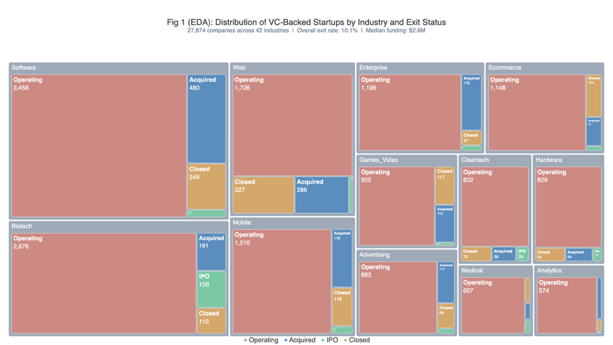  Fig 1. Distribution of VC-Backed Startups by Industry and Exit Status | 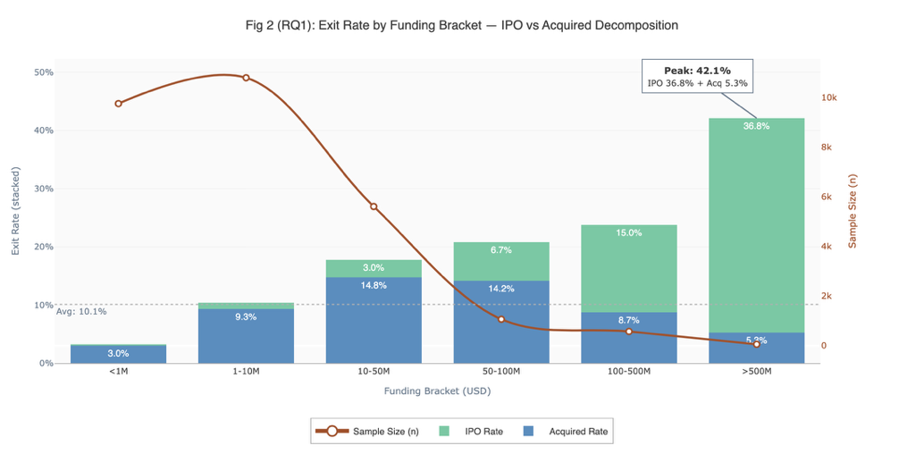Fig 2. Exit Rate Decomposition (IPO vs. Acquisition) by Total Funding Bracket
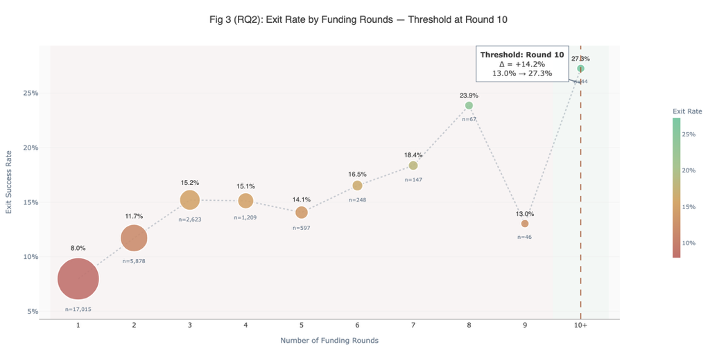  Fig 3. Exit Rate by Number of Funding Rounds with Threshold Identification | 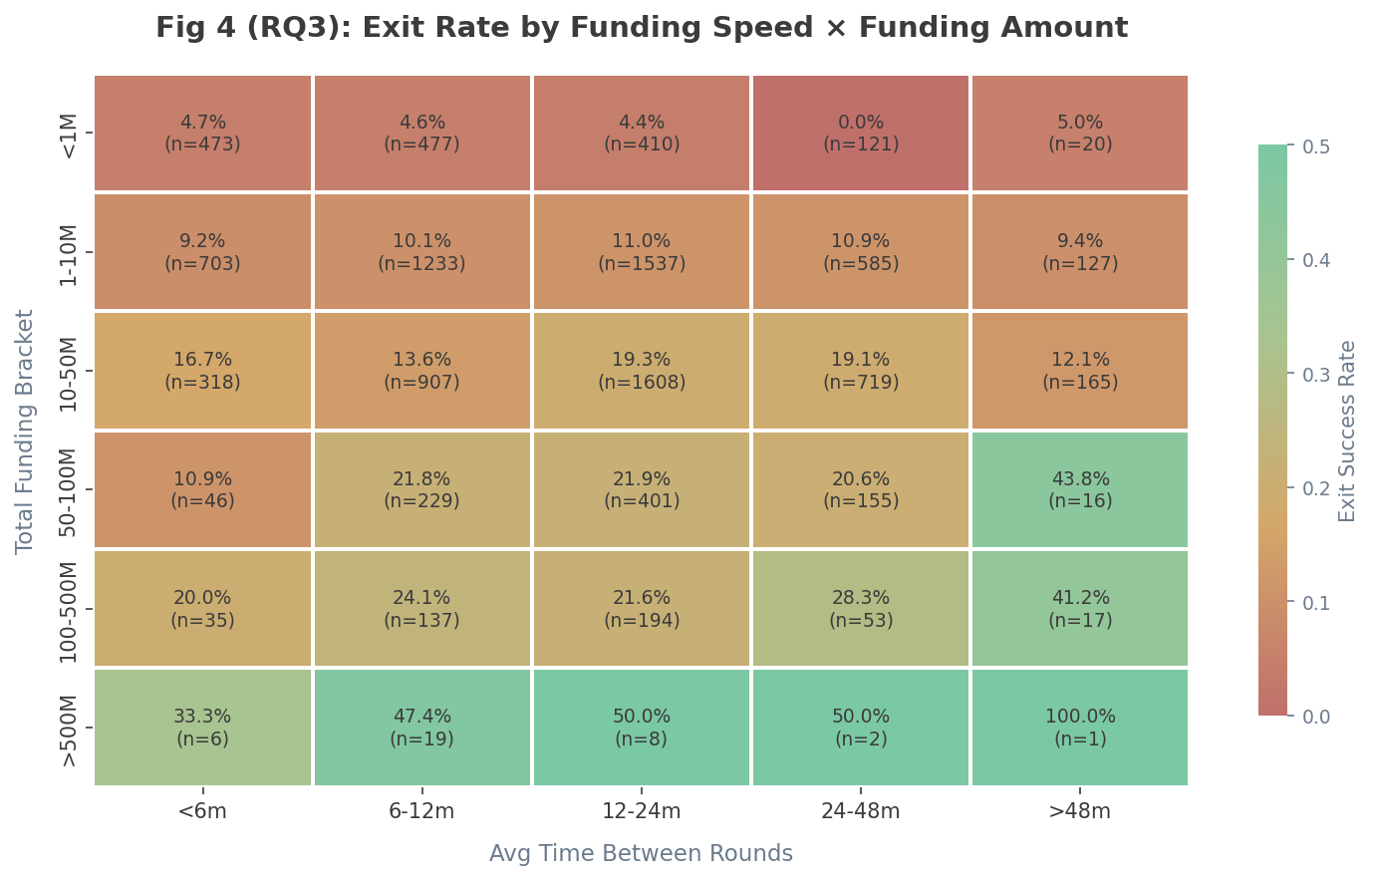Fig 4. Exit Rate Heatmap: Funding Velocity × Funding Volume Interaction

